Year 6 will sit their SATs from the Monday 11th May to Thursday 14th May 2026.
Please see timetable below.
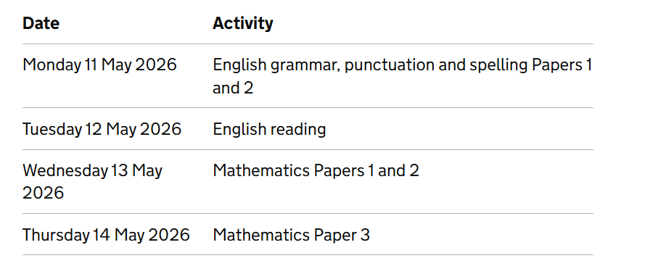
More information will follow shortly.

